**LAB#6**

**Object:** Write a program to compare two numbers and print the smallest number.

dosseg

.model small

.stack 100h

.data

num1 db ?

num2 db ?

msg1 db 10,13,"ENTER FIRST NUMBER TO COMPARE: $"

msg2 db 10,13,"ENTER SECOND NUMBER TO COMPARE: $"

msg3 db 10,13,"SMALLER NUMBER IS: $"

.code

main proc

mov ax,@data

mov ds,ax

lea dx,msg1

mov ah,9

int 21h

mov ah,1

int 21h

mov num1,al

lea dx,msg2

mov ah,9

int 21h

mov ah,1

int 21h

mov num2,al

lea dx,msg3

mov ah,9

int 21h

mov al,num1

cmp al,num2

jg second

first:

mov ah,2

mov dl,num1

int 21h

jmp exit

second:

mov ah,2

mov dl,num2

int 21h

exit:

mov ah,4ch

int 21h

main endp

end main

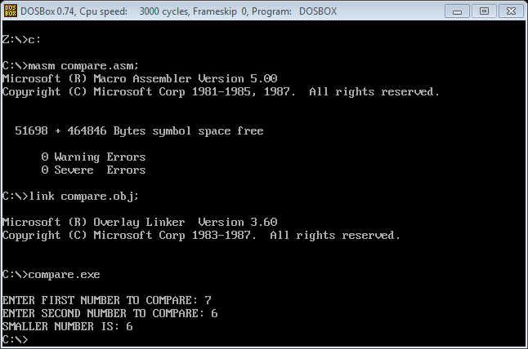

**Object:** Write a program to check that the two numbers equal or unequal.

dosseg

.model small

.stack 100h

.data

m1 db "ENTER FIRST NUMBER: $"

m2 db "ENTER SECOND NUMBER: $"

m3 db 0DH,0AH,"EQUAL NUMBER $"

m4 db 0DH,0AH,"UNEQUAL NUMBER $"

a db ?

.code

main proc

mov ax,@data

mov ds,ax

mov ah,9h

lea dx,m1

int 21h

mov ah,01

int 21h

mov a,al

mov ah,02

mov dl,10

int 21h

mov ah,9h

lea dx,m2

int 21h

mov ah,01

int 21h

sub a,al

jnz abc

mov ah,9h

lea dx,m3

int 21h

mov ah,4ch

int 21h

abc:

lea dx,m4

mov ah,9h

int 21h

main endp

end main

